1. How are the monthly returns of possible portfolios distributed?

The monthly returns of possible portfolios is skewed right. We have in all 10 cases athe mean > median.

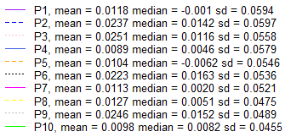

2. Do you see a wide variance in the possible portfolio returns and its cumulative outcome?

I see a wide variance in the possible portfolio returns. It seems that the diversification benefits are low in this case (health plan industry). These are the individual standard deviations and the standard deviation of each one of the 10 portfolios. We can observe that they are indeed very similar.

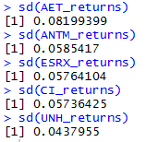 

Also, the sharp ratio of all porfolios is low. So risk adjusted we are facing a high risk in these porfolios. For comparision, the minimum sharp ratio that the Alpha Sim challenge demands is 1.25.



It is possible that the majority of risk comes from the industry and not from the companies, at least in this case. A possible explanation is all the discussion regarding Obama Care and Donald Trump election. As it is possible to see in the graph below, in the 5th month we were having negative returns in most porfolios. Then we had a sharp spike and great positive returns in all portfolios. The high returns were achieved with high standard deviations.

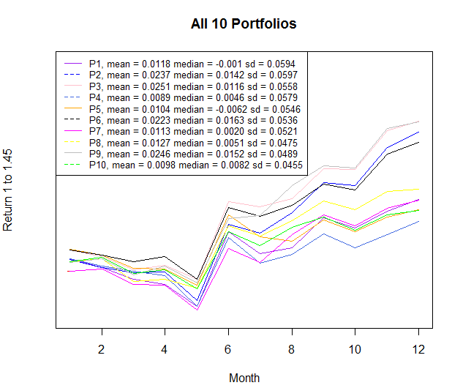

1. Given that you chose similar stocks from the same industry, what accounts for the variance of returns among different portfolios (if any)?

It seems that diversification does not accomplish a significative improvement in the variance / standard deviation of the portfolio. Most portfolios have a higher variance than the individual company UNH for example. All portfolios had a similar variance too. A possible explanation was the high systemic risk due to political reasons (Obama Care x Trump) in the period studied. The diversification was not able to mitigate considerably the idiosyncratic risks.